Batch: A2 Roll. No.:16010122034
Experiment: 10
Grade: AA / AB / BB / BC / CC / CD /DD

Title: Using virtual labs to understand the data structures

Objective: Use of virtual labs to understand the concepts and theory with examples and verify the same with practice questions.

Expected Outcome of Experiment:

CO | Outcome
CO1 | Explain the different data structures used in problem solving
CO2 | Apply linear and non-linear data structure in application development
CO3 | Demonstrate sorting and searching methods.

Websites/books referred:
- geeksforgeeks.org/

Abstract: the virtual lab experiments help in understanding how various data structures work. They also emphasize on some important applications of various data structures and enable students to get familiarized with how certain applications can benefit from the choice of data structures.
Assigned data structure: (Teacher would assign one of the following to one student)
- Hash tables - https://ds1-iiith.vlabs.ac.in/exp/hash-tables/quadratic-probing/qp_practice.html

Aim / learning objective of the assigned expt:
- Learn about quadratic probing.
- Practice quadratic probing methods through interactive activities.
- Understand the differences between linear and quadratic probing.

Concept and algorithm of the application/activity followed:
Quadratic Probing:
Quadratic probing is an open-addressing scheme where we look for the i2‘th slot in the i’th iteration if the given hash value x collides in the hash table.
How is Quadratic Probing done?
Let hash(x) be the slot index computed using the hash function.
- If the slot hash(x) % S is full, then we try (hash(x) + 1*1) % S.
- If (hash(x) + 1*1) % S is also full, then we try (hash(x) + 2*2) % S.
- If (hash(x) + 2*2) % S is also full, then we try (hash(x) + 3*3) % S.
- This process is repeated for all the values of i until an empty slot is found.

Demo execution screenshots:
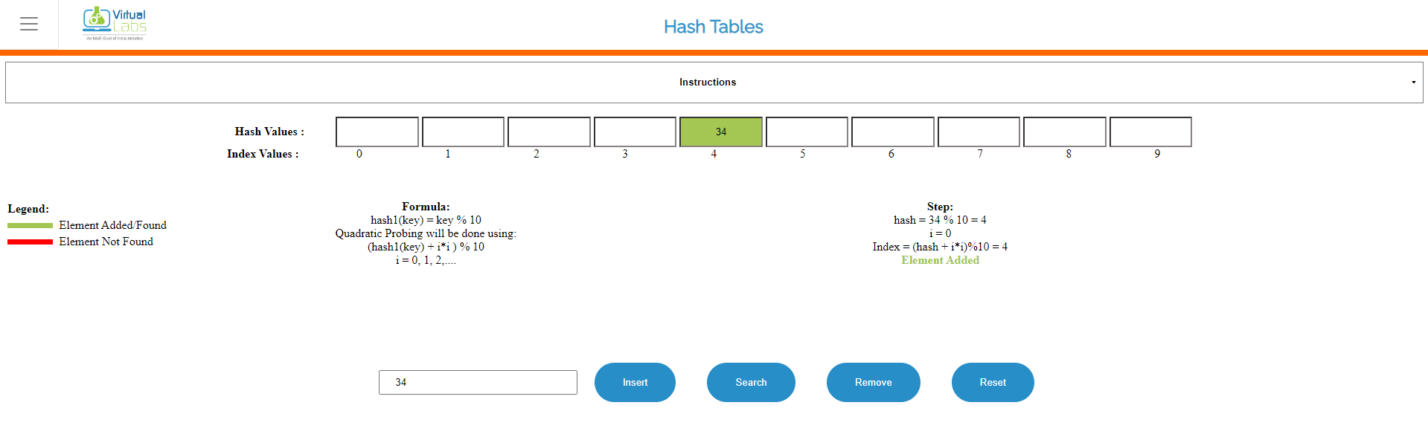
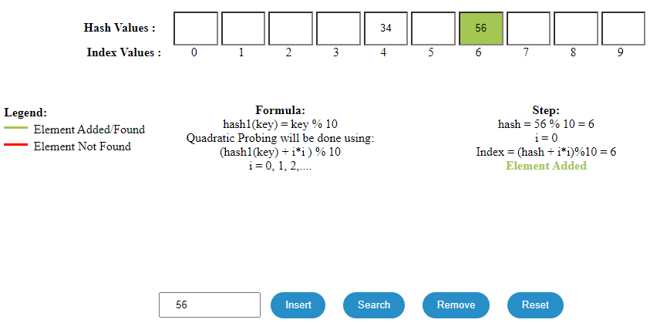
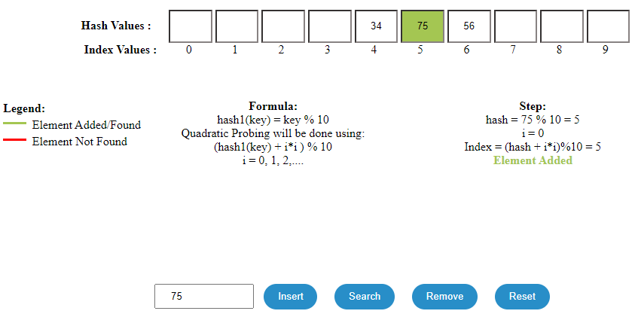
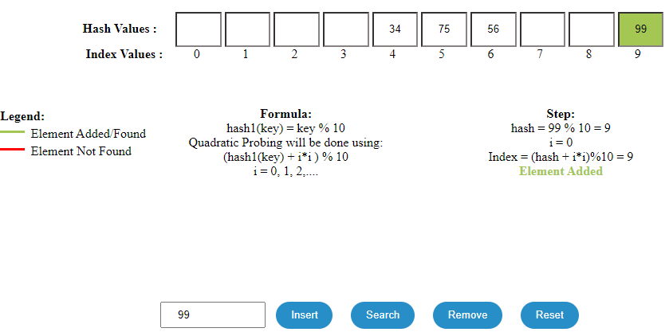
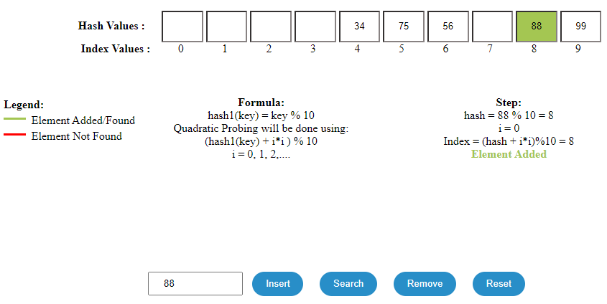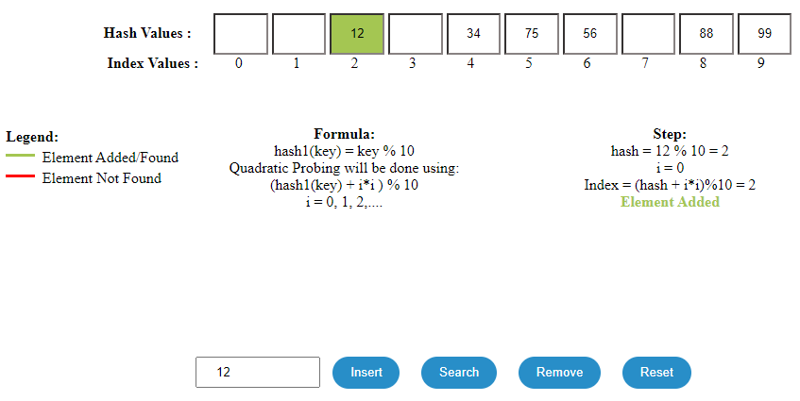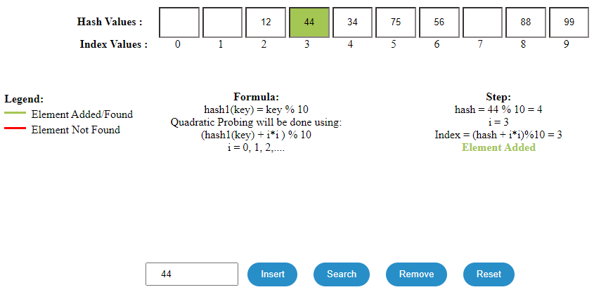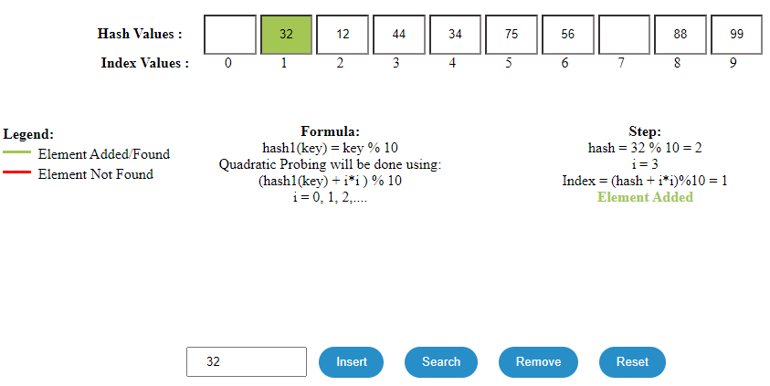
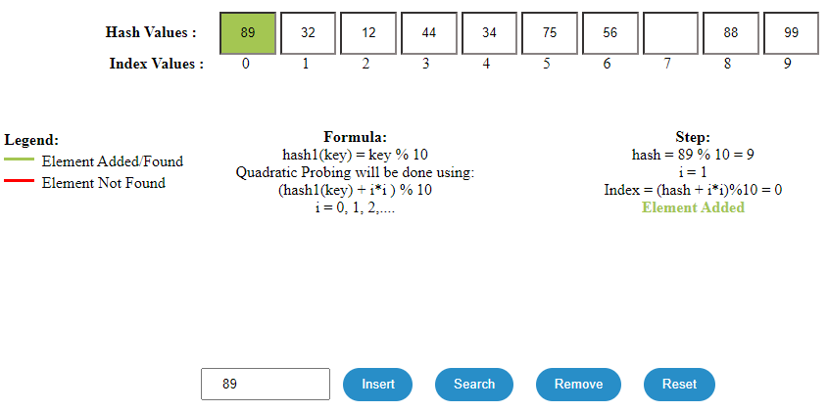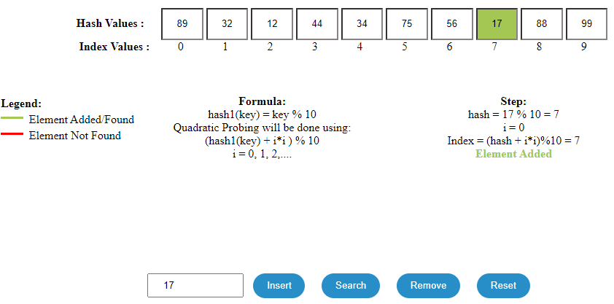

Searching:
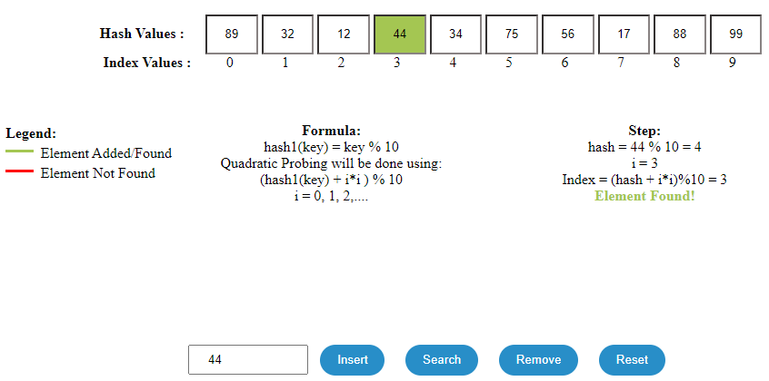
Practice problem screenshots: 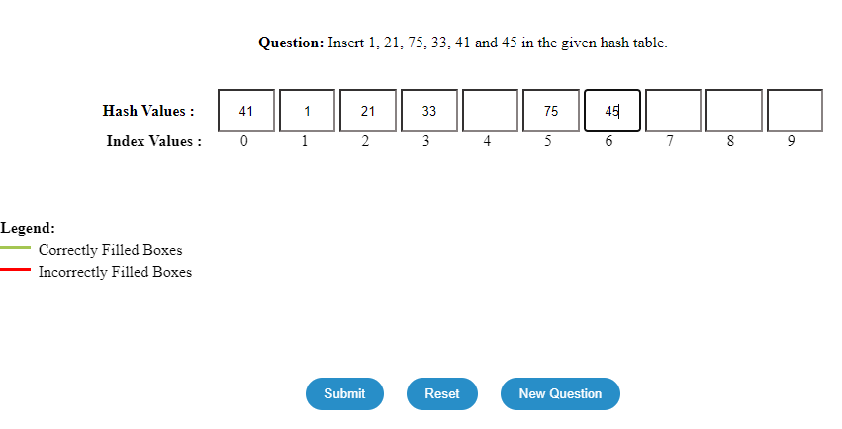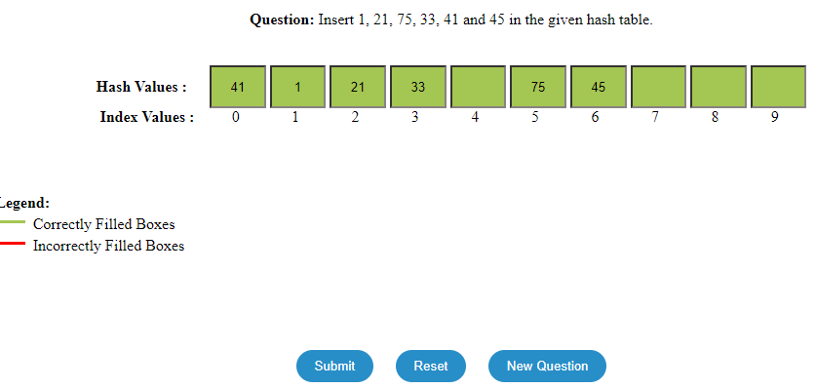

Quiz screenshots:
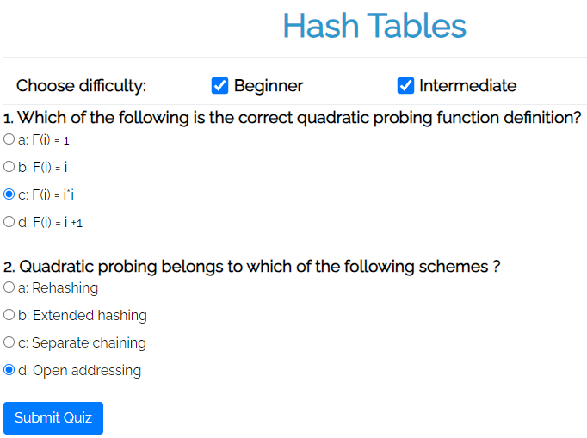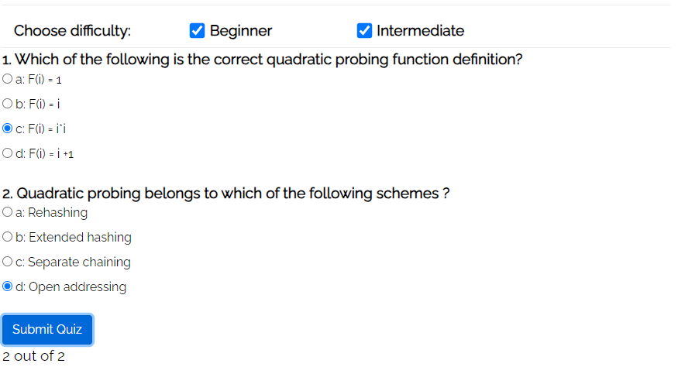

Conclusion and your take away after performing the virtual lab experiment: -
This virtual lab taught me how to use quadratic probing to quickly insert elements into a list as well as search for elements. There were times that this method of probing was stuck in a cycle. So, it may be inadequate for production.

